**Exercise 12: Getting familiar with MongoDB Compass**

**Name Đoàn Nam Sơn DE180896**

# Objective

In this exercise, you'll learn about MongoDB Compass that is the official graphical user interface (GUI) for MongoDB. It provides a user-friendly way to interact with your MongoDB databases, making it easier to manage your data, run queries, and visualize your database schema without needing to use the command line or write any code. Compass supports all the features of MongoDB, including CRUD operations, indexing, aggregation pipelines, and more, through an intuitive and accessible interface

# Exercises

## Exercise 1: Do all requirements basing on the articles in db.json file

* Create database namely Newspaper

* Create a collection named articles and insert a new article

* Insert many articles in articles collection

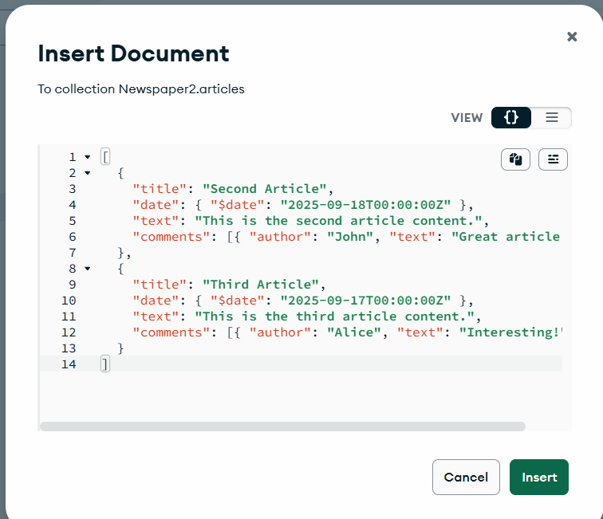

* Retrieve the document you just inserted



* Add another comment in available articles

* Delete a specific comment made by "Alex" from an article

## Exercise 2: Do all requirements basing on the videos in db.json file

* Create a collection named video and insert a new video

* Insert many videos in videos collection

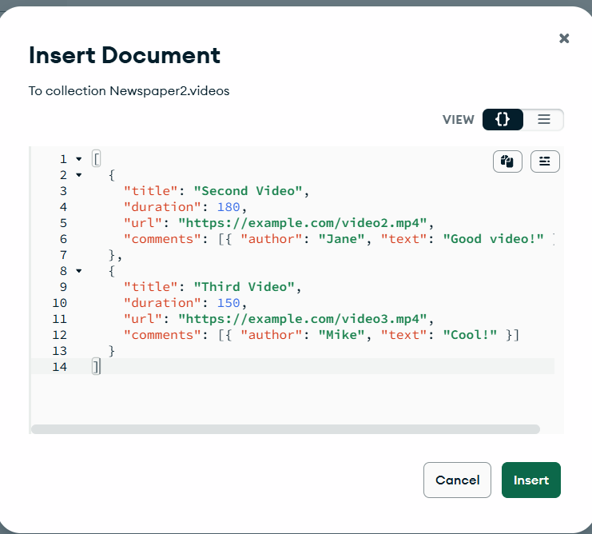

* Find the video by its title

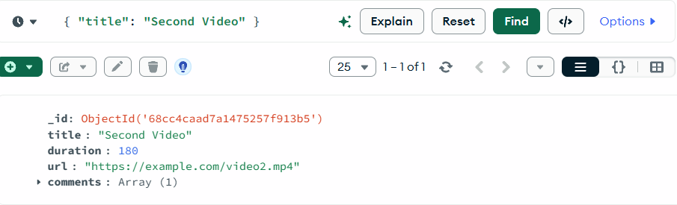

* Update the video's content

Change URL from this:

To This:

And click Update

* Add another comment in available video

# Conclusion

This exercise aims to practice these basic commands and exploring more complex operations. You'll become more comfortable with managing and querying your MongoDB databases using Mongo Compass.